SPEEDTEST MODULE

# 

# CONTENTS

1. MODULE_SPEEDTEST.docx
2. MODULE_SPEEDTEST_MEDIA.zip

# A1. Landing Page

Create a dashboard admin page design consisting of navigation bar, search, logo, sidebar menu, statistics (total users, total sales, total revenue, total bookings) and chart. You have to save the design file: **.psd, .ai or .xd** and exported file: **.png.**

# B1. Flipkart

In a centered page, you need to make a card as shown in the image below.

** **

When the card is hovered, create a flip animation like **example.mp4**.

# 

# B2. Follow the Path

Make a Pac-Man animation that follows the path around the building in the middle. See **example.mp4** for more details.

 

# **B3. Masking Text**

Create a clipping mask with text. Transparent text on top of your image. The text will change between "LKSN XXXII" and "LAMPUNG 2024" every 3 seconds. You can use **duar.webp** as background. See **example.mp4** for more details.





# **C1. XYZ Move**

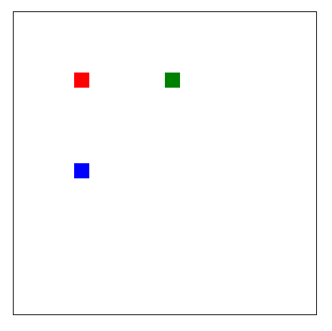 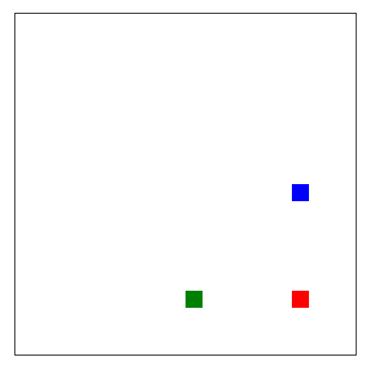

Create a 400 x 400 canvas with 3 squares of different colors moving back, from top to bottom, left to right and diagonally.

# 

# **C2. Rain Forest**

Create a 600 x 500 canvas and create a random rain animation with transparent text "Rain Forest" in the middle of the canvas. Please see the given video example provided.

# 

# **C3. Live Data**

You need to make a live data chart with random data that will update every second. The canvas should be 500x300 in size and centered both vertically and horizontally in the browser. See **example.mp4** for more details.

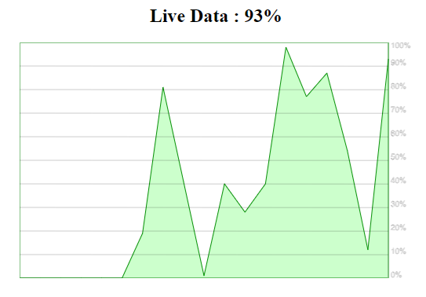

# **D1. Roman Converter**

Create a function that will take either a string containing a roman numeral, or an integer.

I ➞ 1

V ➞ 5

X ➞ 10

L ➞ 50

C ➞ 100

D ➞ 500

M ➞ 1000

Input a string, return the integer value of that roman numeral. Given an integer, return the equivalent roman numeral.

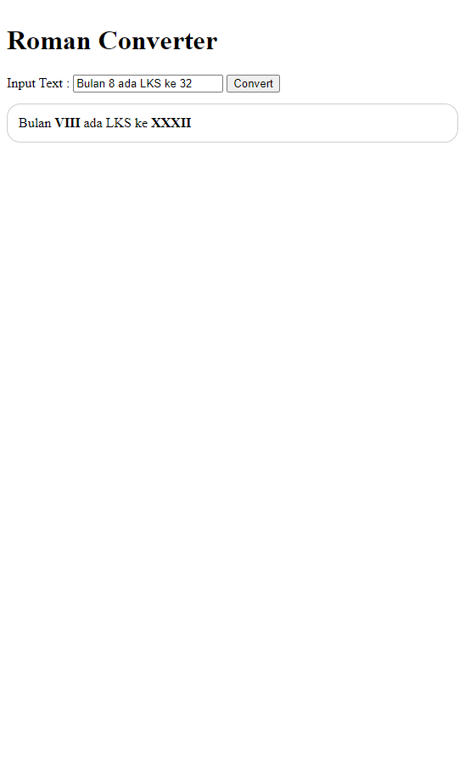

# 

# D2. Simple Noticeboard

Create a simple noticeboard for post and display on the same page. This page shows all logged posts. And there is a form in the same page to create new posts, update and delete, that saves to log.json.

* JavaScript is not available
* Save post data to "log.json"
* Input content should be "name" and "content"
* Update and delete posts can work

Display "name", "content", and "post date."

Example:

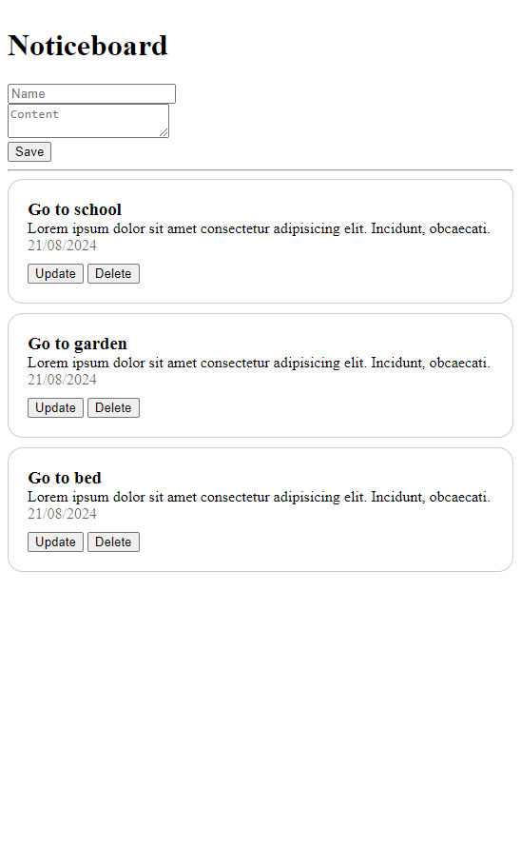

# D3. Tic-Tac-Toe PHP

Create a Tic-Tac-Toe game, according to the following requirements:

1. When you click a cell, your piece “X” is placed in the cell, and the robot who operates the “O” will place a piece randomly.
2. If you click the reset button, the game will be initialized, the win prompt will be hidden.
3. The win prompt will be hidden at initial status.
4. If you refresh the page, game status should not be initialized.
5. All data should be stored in the backend.
6. The page data should be taken from the backend.

Example: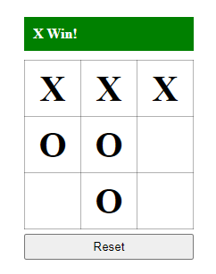

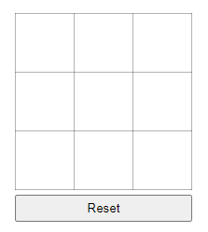

# INSTRUCTION FOR COMPETITORS

1. Create a root folder called **XX_SPEEDTEST_MODULE** in your local computer, where **XX** is your **computer number**.
2. Create a sub folder for each task (A1, B1, etc.) and store it inside the root folder.
3. Zip your root folder **XX_SPEEDTEST_MODULE** and submit to the submission page.